****

**LocAdoc**

**User Manual**

**Version 1.0**

**Prepared by: Abhi Jay Krishnan**

**Kim Hyeocheol**

**Rivaldo Erawan**

**Durrah Afshan**

Table of Contents

[1. Introduction 1](#_Toc498625796)

[1.1 Reference 1](#_Toc498625797)

[2. User flow design 1](#_Toc498625798)

[2.1 User flow diagram 1](#_Toc498625799)

[2.2 User flow description 1](#_Toc498625800)

[3. UI designs 2](#_Toc498625801)

[3.1 Login 2](#_Toc498625802)

[3.2 Signup 4](#_Toc498625803)

[3.3 Forgot password(Password Recovery) 6](#_Toc498625804)

[3.4 Home Screen 8](#_Toc498625805)

[3.5 Home screen (searching area) 9](#_Toc498625806)

[3.6 Home screen (file explorer) 11](#_Toc498625807)

[3.7 Home screen (file operations) 12](#_Toc498625808)

[3.8 PDF viewer 13](#_Toc498625809)

[3.9 Main Menu (Navigation Menu) 14](#_Toc498625810)

[3.10 Add Area 15](#_Toc498625811)

[3.11 Area Operation 16](#_Toc498625812)

[3.12 Add Documents(Import Documents) 18](#_Toc498625813)

[3.13 Settings 19](#_Toc498625814)

[3.14 Change User Name 20](#_Toc498625815)

[3.15 Change password 21](#_Toc498625816)

[3.16 Download Backup Files 22](#_Toc498625817)

[3.17 About 23](#_Toc498625818)

# Introduction

The purpose of this document is to provide a complete description of the user interface that would-be part of the completed LocAdoc application.

The main scope of this document is to:-

* + Get a clear understanding on how user will transit between different activities.
  + Get an overview of each interface design.

To readers may wish to refer to software requirement specification sheet for further details on system functionalities.

## Reference

The design in the document is created using Pencil (An open-source GUI prototyping tool).

URL: <https://pencil.evolus.vn/>

# User flow design

## User flow diagram

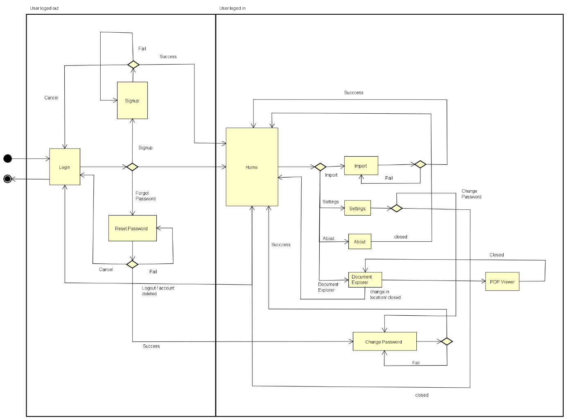

Figure : User flow diagram

## User flow description

User start from login screen, which has 3 functionalities namely login, forget password (reset password) and signup. The user returns to login screen if they logout from application or cancel signup or rest process.

Once the login is successful the moves on to the home screen which is the central location that links to all system functionalities such as location map, brows file based on area, import document and menu with settings, help and about functions.

Setting have options the change password and to change user details. The user may wish to delete account from settings.

Document explorer is based on the area the user is currently in and the user may wish to view the currently available files or delete them.

# UI designs

## Login

|  |  |
| --- | --- |
|  |  |
| C:\Users\user\Downloads\Screenshot_20171116-150306.png | C:\Users\user\Downloads\Screenshot_20171116-150236.png |

Login screen will give user the option to login, signup, and forgot password. There are two appearances, the left screen is shown when there is no user in the device and the right one is shown if a user has successfully logged in to the device previously.

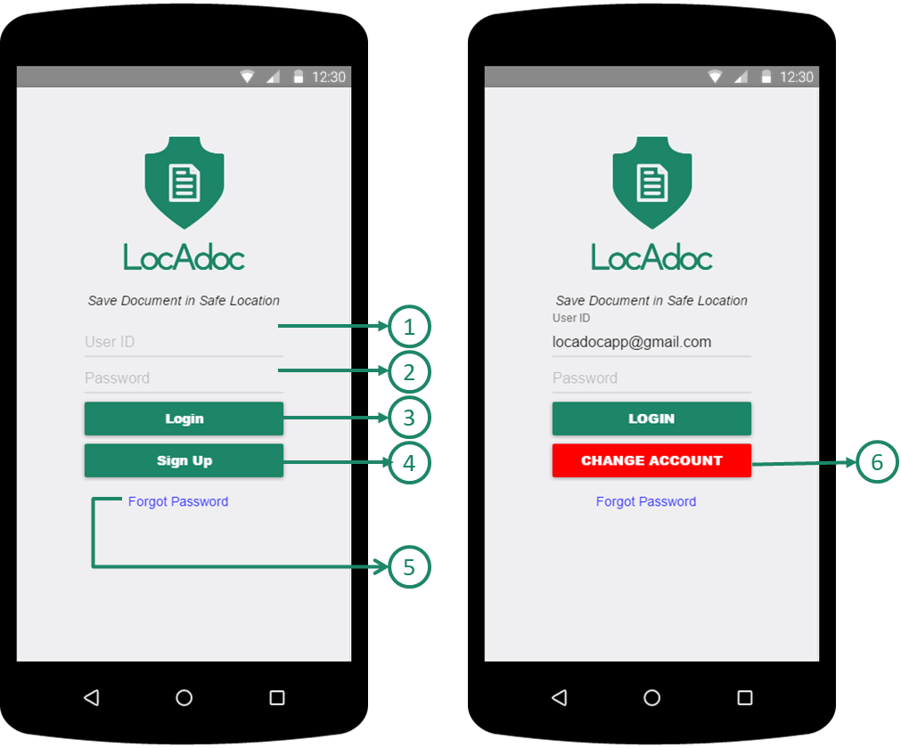

1. **User’s Email Account**: User need to input account’s email
2. **User’s Password**: User need to input account’s password
3. **Login Button**: Login into account with email and password
4. **Sign Up Button**: Go to Sign up Pages to sign up new account **Reference 3.2 Signup**
5. **Forgot Password links**: go to Forgot Password pages. Before access to Forgot Password, user need to write down the account’s email in ①
6. **Change Account button**: Make Empty input in ① fields and allow user to login as another new account

## Signup

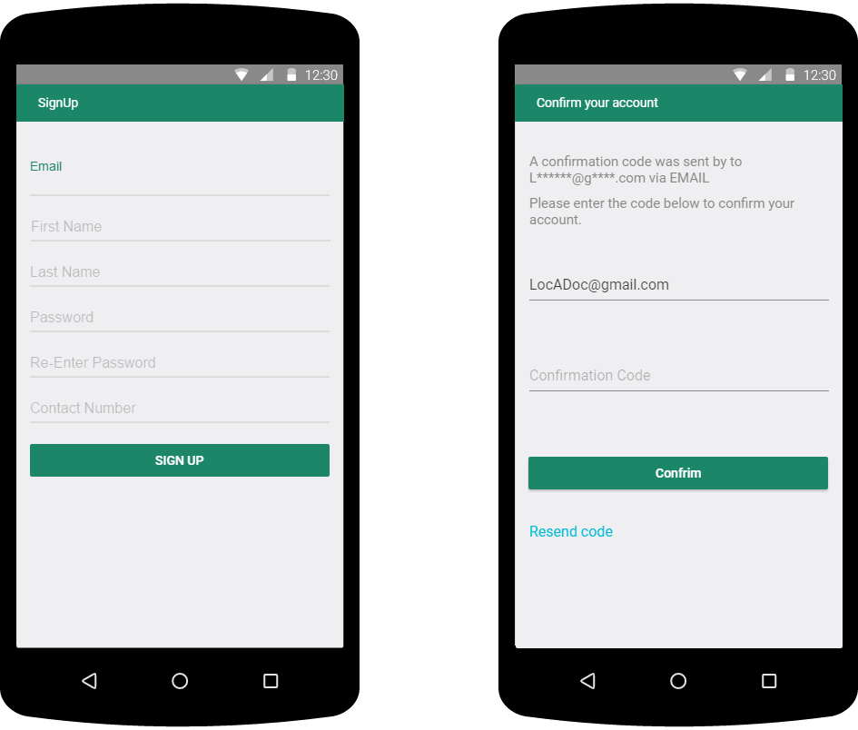

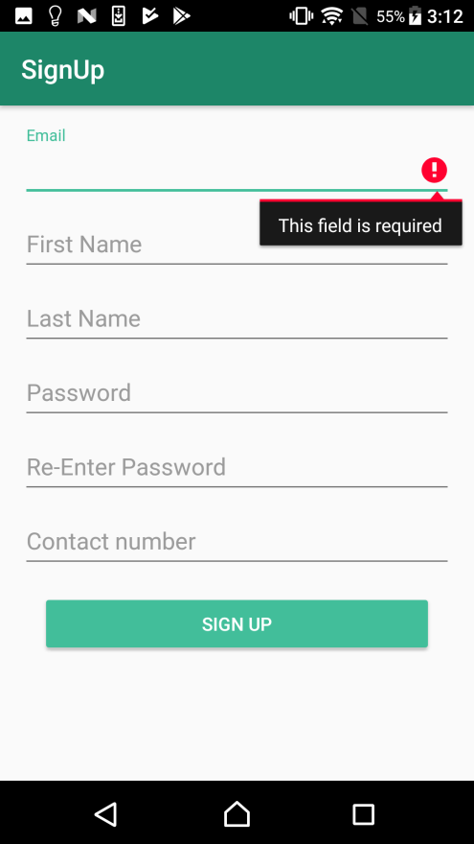 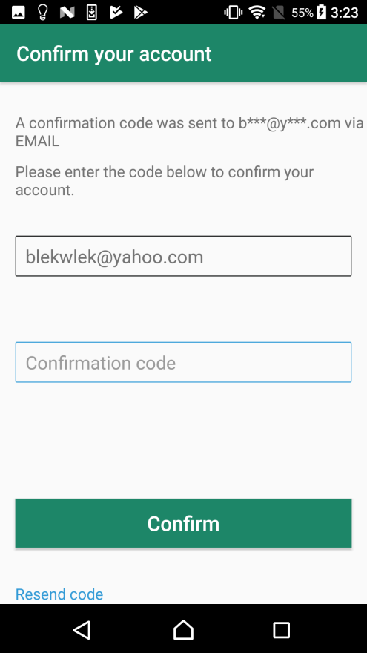

This is the signup form where the user can fill the above information and the system will sign up the user for the services.

**Signup – Signup Form process**

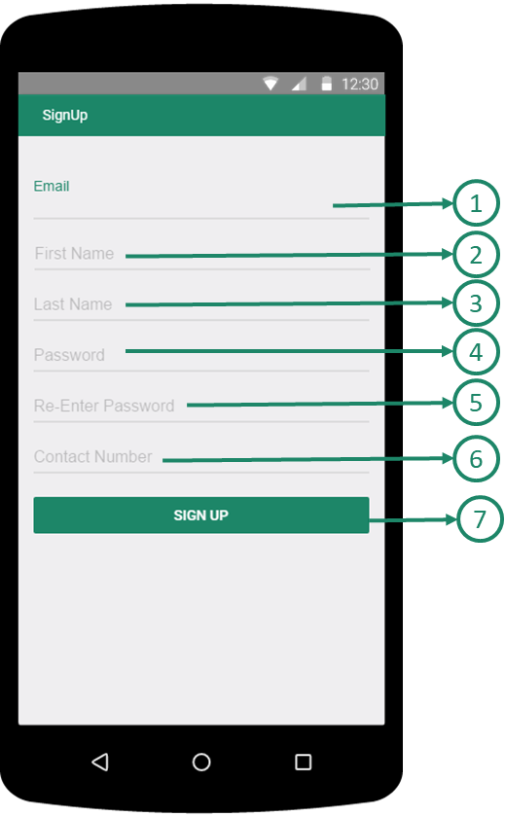 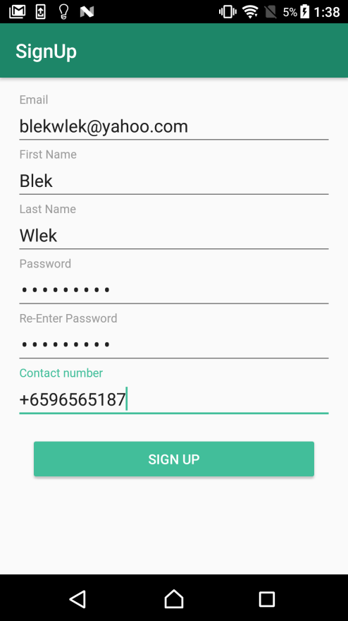

**First Step in Signup**

1. **Email:** User need to input Email Address for Account
2. **First name:** User need to input user’s first Name
3. **Last name:** User need to input user’s Last Name
4. **Password**: User need to input User’s Password, which requires some conditions
   1. The Password should contains both lower case and upper case letters
   2. The Password should contains at least one integer value
   3. The Password length should be between 8 and 12 character
5. **Re-enter password:** User need to input same character as Password
6. **Contact number**: User need to input User’s Contact Number.

Input format should be: (Country Code)(Contact Number)

For Example IF user’s Country is Singapore and Contact Number is 87654321

THEN +6587654321

1. **Signup submission button**: Submission button moving to next verification step in Signup. IF there were wrong format between ① and ⑥, THEN the app will show error message in the wrong field.

**Signup - Verification process in Signup**

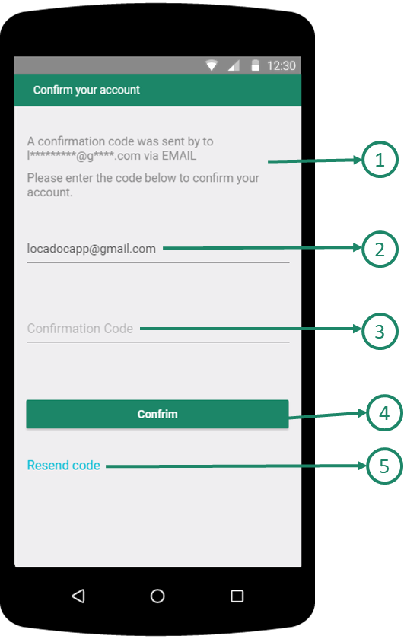 

1. **Application message**: The Application show message that verification code is sent to user’s email that user has written in signup form.
2. **Email**: Email address that user inputs in Signup Form. User cannot change the email address in this step.
3. **Confirmation code**: User need to input Confirmation Code that user receive via Email
4. **Confirmation submission button**: Submission button with verification code.

IF correct verification code, THEN the app will show success message and do auto login.

IF incorrect verification code, THEN the app will show fail message.

1. **Resend code**: IF User click this text, then the app will email another verification code into user email.

## Forgot password (Password Recovery)

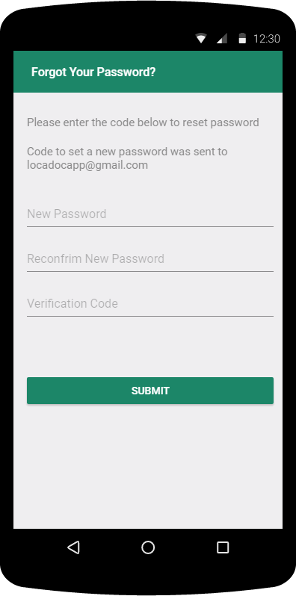 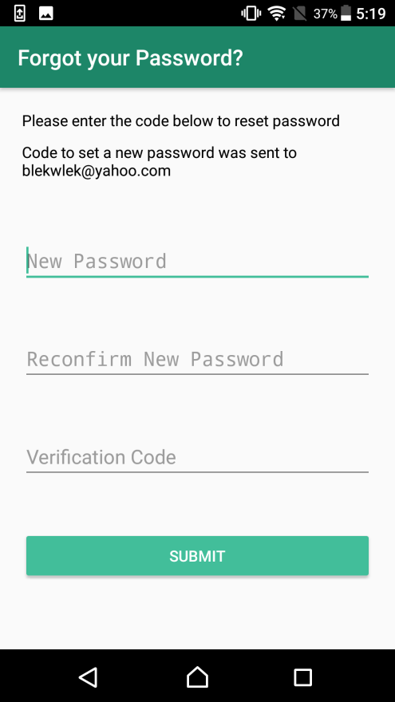

The user will fill up the password reset form and on clicking next a verification code will be send to the email or phone. The second screen the user need to enter the verification code.

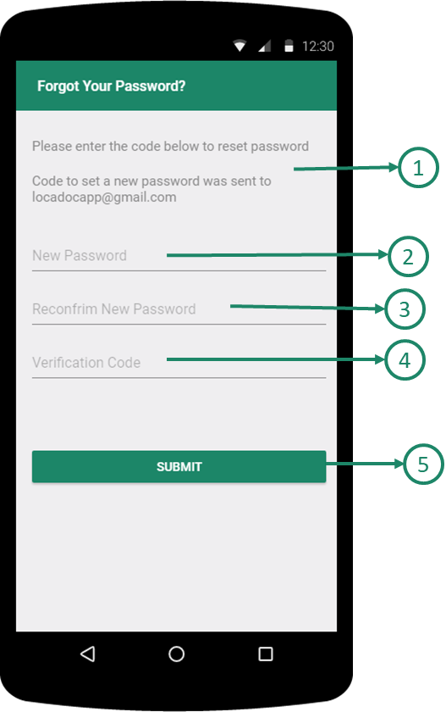 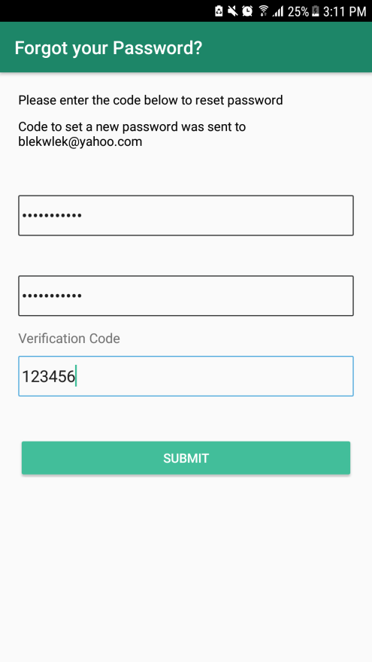

1. **Application Message**: The Application show message that verification code is sent to user’s email
2. **New Password**:User need to input New Password, which requires some conditions, to access account
   1. The new password should contains both lower case and upper case letter
   2. The new password should contains at least one integer value
   3. The new password length should be between 8 and 12 character
3. **Reconfirm New Password**: User need to input same character as new password
4. **Verification Code**: User need to input verification code that user receive via Email
5. **Submission Button**: Submission button with verification code and New Password for Account. **IF** correct verification code, **THEN** the app will show success message and do auto-login with new Password. **IF** incorrect verification code, **THEN** the app will show fail message.

## Home Screen

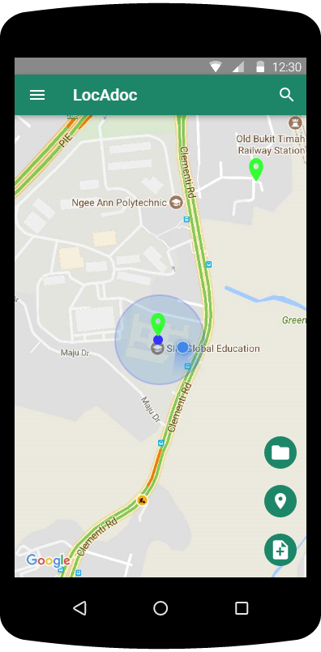 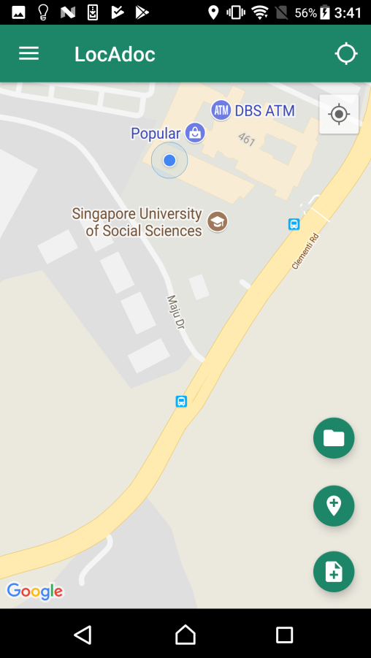

On logging in successfully the user will enter this screen where the user gets to see a map with his current location and the areas near him. The top bar has a menu icon on the left and a search bar. User may click on the blue dot that represents the area to open up all the files in that location. The plus symbol below leads to adding a new document to the current location.

|  |  |
| --- | --- |
|  | 1. **Navigation Menu Button:** Open the Homepage Navigation Menu 2. **Search Area Button**: Change Toolbar to Search bar to find out Area. Reference ***3.5 Home Screen (Searching Area)*** 3. **Area Marker**: Area Marker or Area’s middle point 4. **Middle point of Area in Area Marker** 5. **Current Location:** This marker shows the user’s current location. 6. **File Explorer Button**: Open File Explorer to view Documents.   Reference ***3.6 Home Screen (browser file)***   1. **Add Area Button**: Open new Screen below to the homepage to add New Area **Reference 3.10 Add Area** 2. **Add Documents Button**: Open new Screen below to the homepage to add documents in either new area or existed area **Reference 3.12 Add Documents(Import Documents)** |

## **Home screen (searching area**)

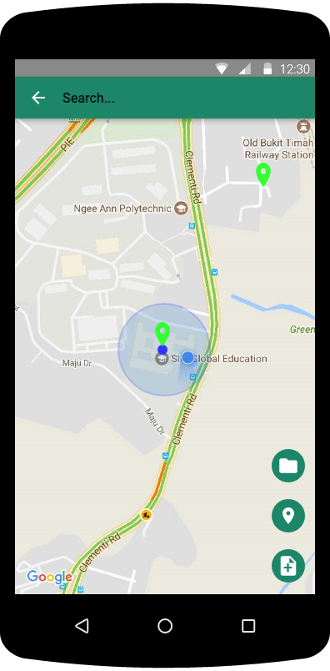 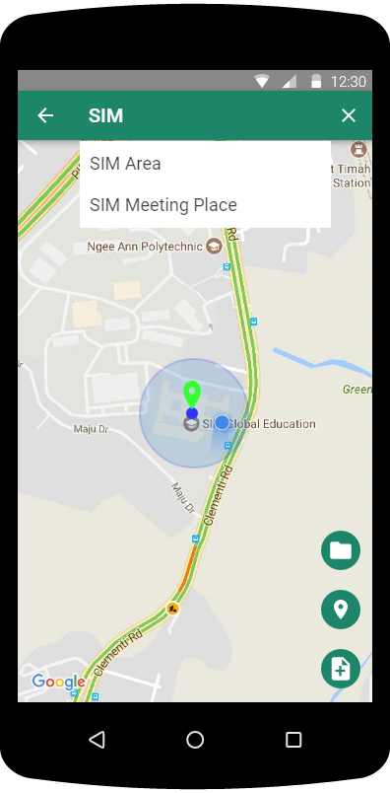

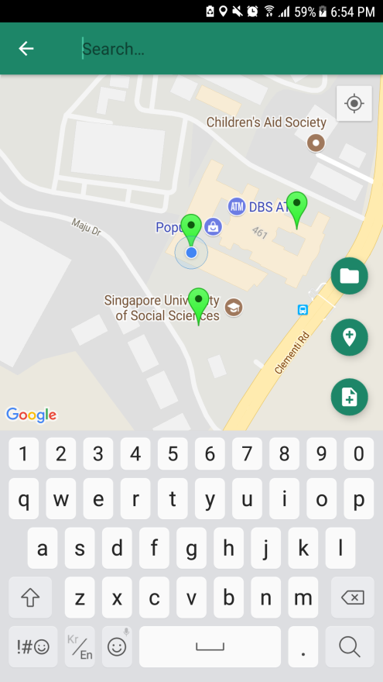 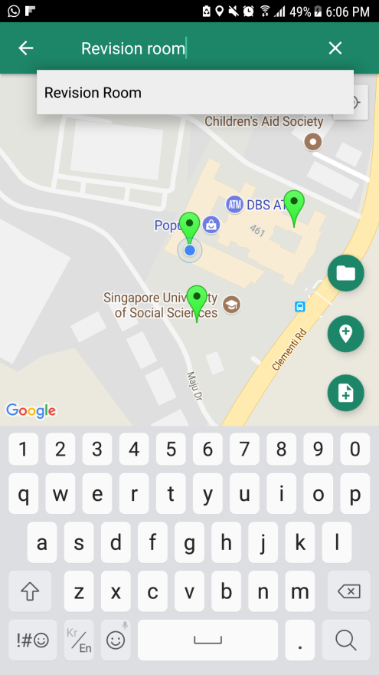

The user can search all the area from the search bar but can only access the files under that area if he/she is in that location.

|  |  |
| --- | --- |
|  | 1. **Go Back Button**: Go Back to Homepage screen 2. **Search Bar**: should type the name of area to find 3. **Clean Button**: Clean the input in Area search bar 4. **Result List in Search**: show the Result of Area list depends on the input in Search Bar |

## **Home screen (file explorer**)

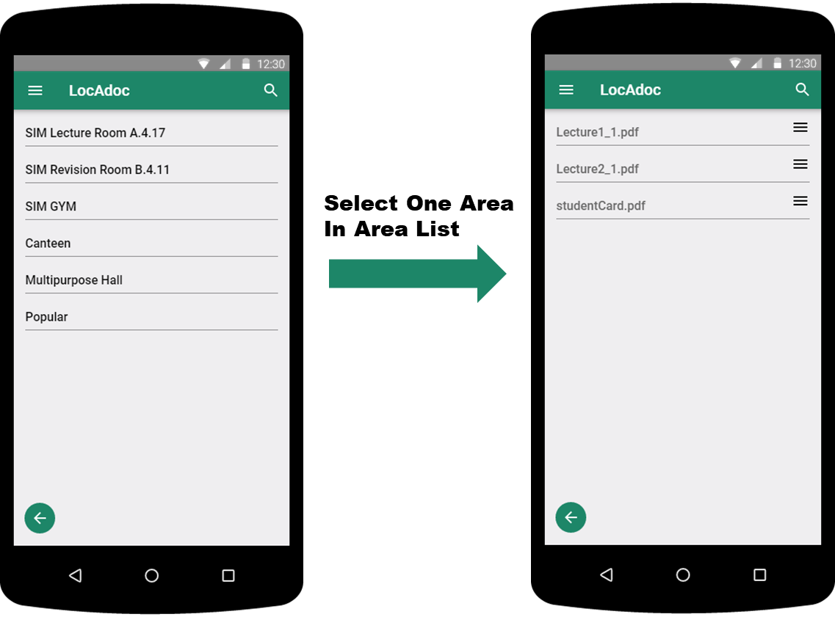

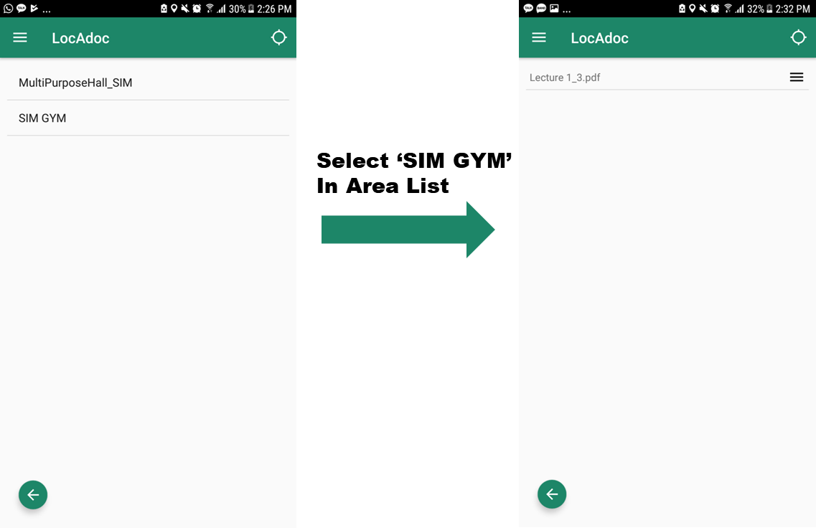

The app will list out all the files that is available in the current area. This screen can be approached by tapping the location pointer on the home screen map.

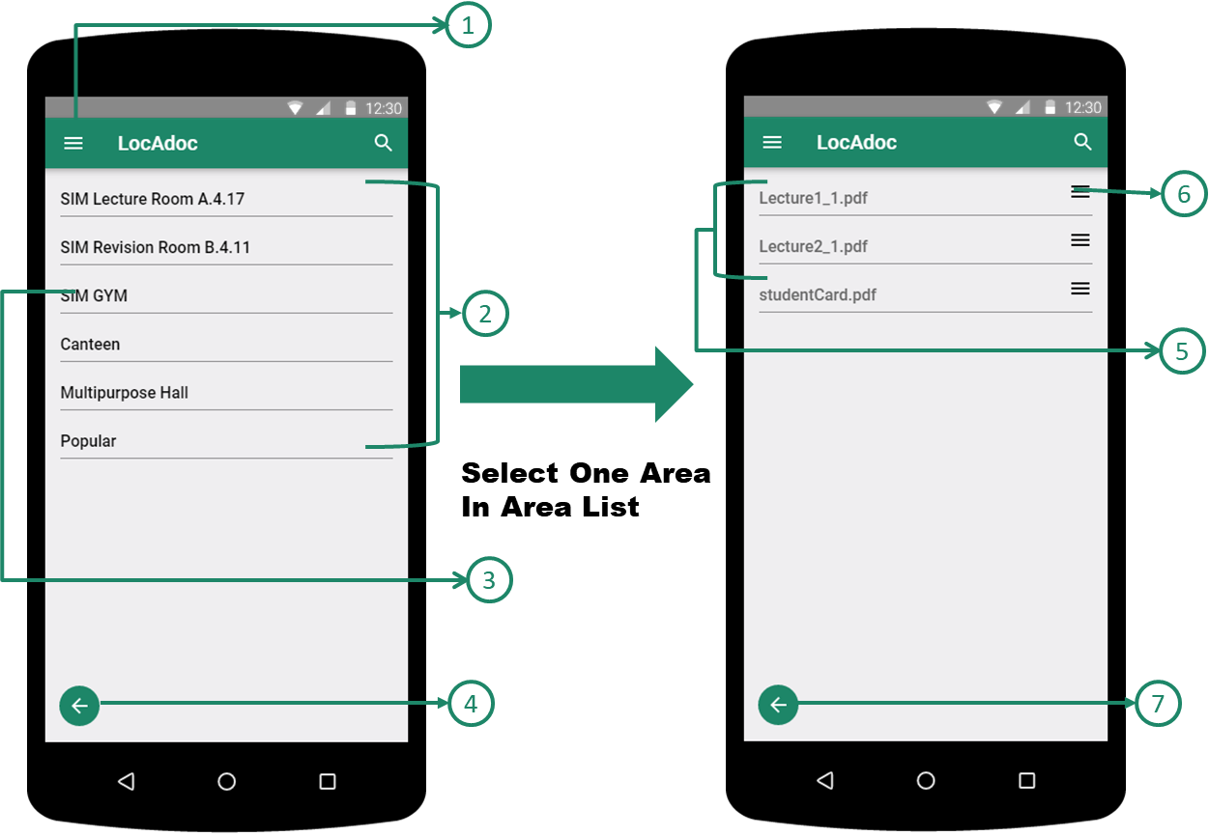

1. **Main Menu (Navigation Menu) Button**: Open the Homepage Navigation Menu
2. **Area List**: Available Area List depends on the current Location
3. **One Area in Area List**: Area menu in Area Lists to view document lists.
4. **Go Back Button in Area List**: Go back to Homepage
5. **Document List in specific Area**: Available Documents list depends on the selected area.

Clicking any of these will open the files

1. **Document/File Operation Button**: Open the File Operation Dialog
2. **Go Back Button in Document List**: Go back to Area list

## Home screen (file operations)

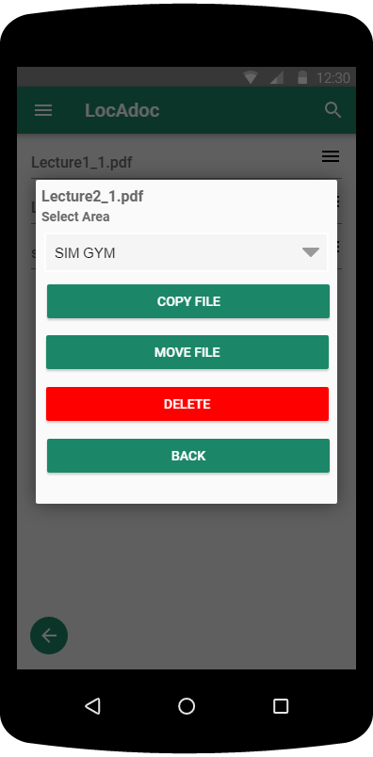 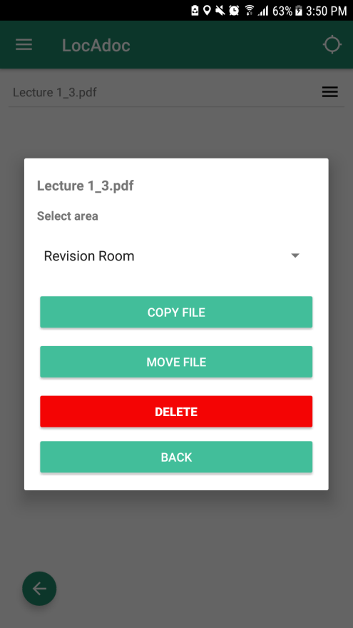

On clicking the 3 lines, a menu will drop down asking if they wish to copy, move, or delete the file

|  |  |
| --- | --- |
|  | 1. **Selected File Name** 2. **Other Areas Name List**: Destination Area to process File Operation 3. **Copy Button**: Copy the selected file into Destination Area depend on the selection in ② 4. **Move File Button**: Move the selected file into Destination Area depend on the selection in ② 5. **Delete File Button**: Delete the Selected file in the area 6. **Go Back Button**: Close the File operation menu |

## PDF viewer

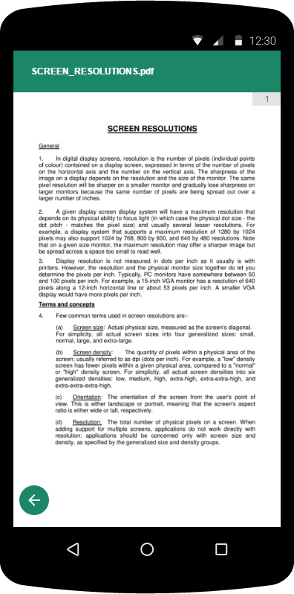

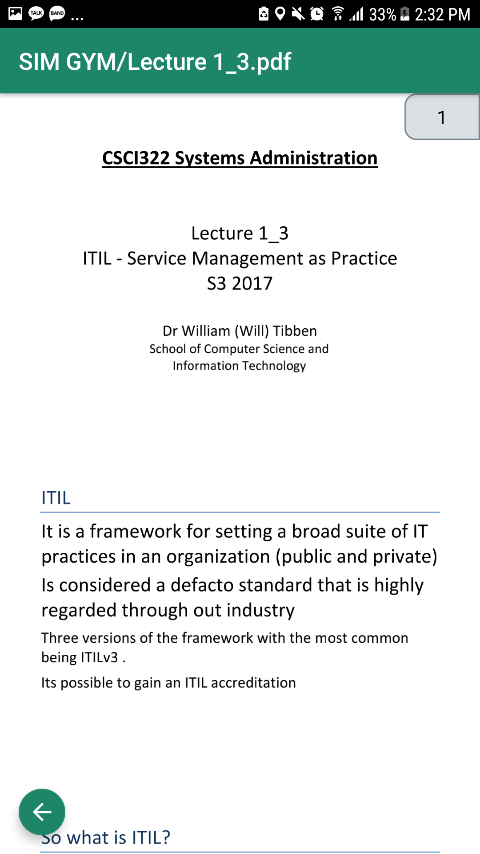

On clicking an item in the file list, the application renders the PDF file and loads up on the screen.

|  |  |
| --- | --- |
|  | 1. **Go Back Button in PDFViewer:** Go back to Documents list Menu in specific Area 2. **Page Scroll Bar:** Scroll bar showing current pages 3. **PDF Viewer Screen**: show the page’s contents |

## Main Menu (Navigation Menu)

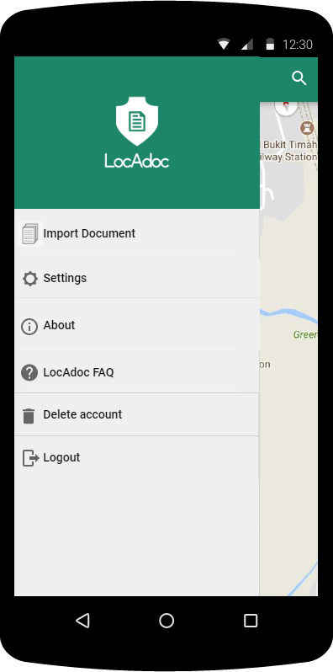 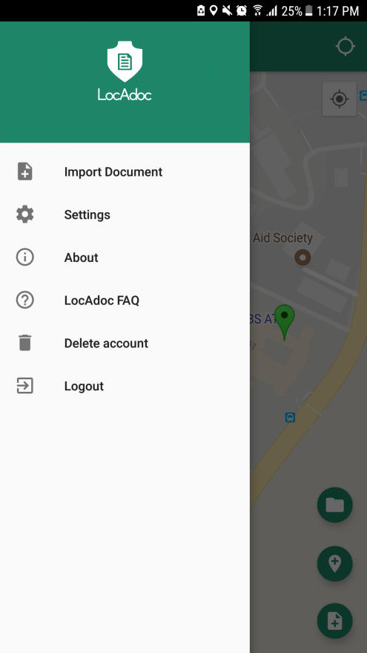

Main menu loads up when we click the icon on the main activity. It has options to add a new document, settings, about, a FAQ link and a logout option.

|  |  |
| --- | --- |
|  | 1. **Import Document Menu**: Open new features below the homepage screen to import the files into area **Reference 3.12 Add Documents(Import Documents)** 2. **Settings Menu**: Go to Setting Menu **Reference** **3.13 Settings** 3. **About Menu**: Show the introduction about LocAdoc **Reference 3.17 About** 4. **LocAdoc FAQ menu**: Open LocAdoc FAQ as web pages 5. **Delete Account menu**: Delete current account 6. **Logout Menu**: Logout from current session |

## Add Area

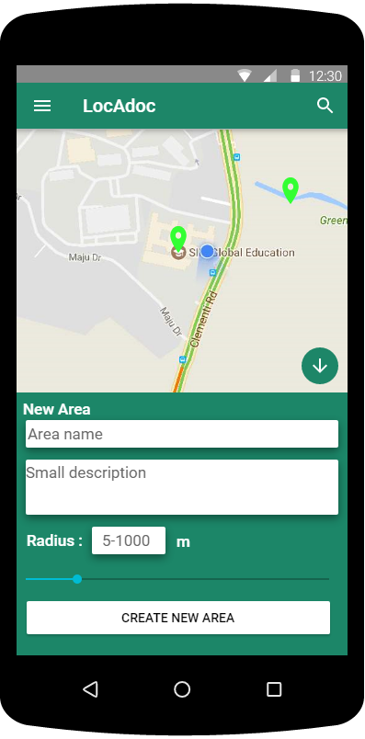

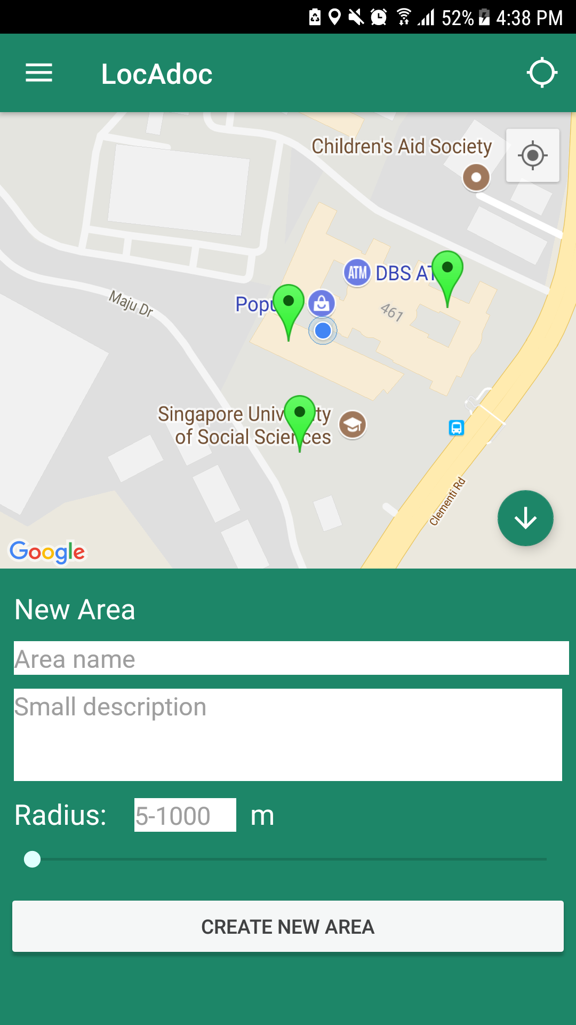

On clicking the Add Area Button, a form to add area will appear from the bottom of the screen and all the buttons will be replaced with Hide Button

|  |  |
| --- | --- |
|  | 1. **Hide Button:** Hide add area form and show the home screen back in full screen 2. **Area Name:** New area name (cannot be empty and must be at least 2 characters) 3. **Area Description:** New area description 4. **Radius Text:** Radius of the new area, editable with keyboard upon clicking the box. Radius value must be between 5 to 1000 meters. 5. **Radius Slider:** Slider to change the radius. 6. **Submit Button:** Create new area |

## Area Operation

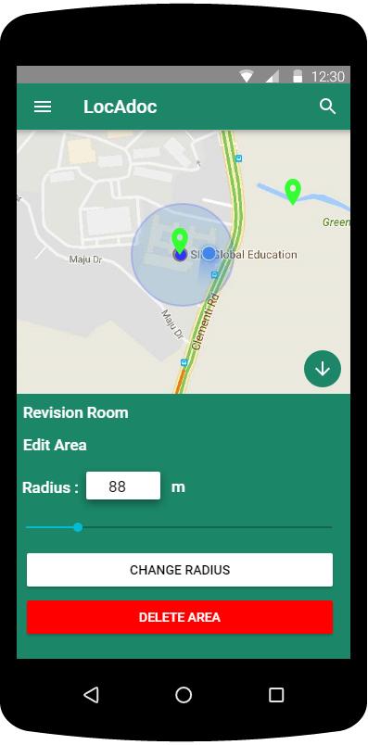 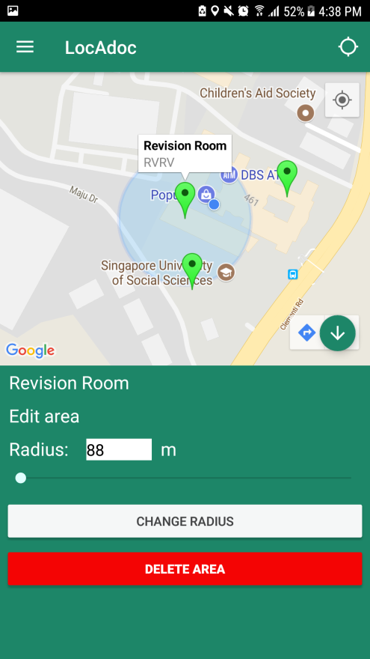

On clicking the marker on the map, if the user is within that area’s radius then a form to edit area’s radius or delete the area will appear from the bottom of the screen and all the buttons will be replaced with Hide Button

|  |  |
| --- | --- |
|  | 1. **Hide Button:** Hide add area form and show the home screen back in full screen 2. **Radius Text:** Radius of the new area, editable with keyboard upon clicking the box. Radius value must be between 5 to 1000 meters. 3. **Radius Slider:** Slider to change the radius. 4. **Change Radius Button:** Change the radius of the selected area to the radius inside radius text. 5. **Delete Area Button:** Delete the selected area. If there is still a file inside the area, then user need to delete all the files first before being able to delete it. |

## Add Document (Import Documents)

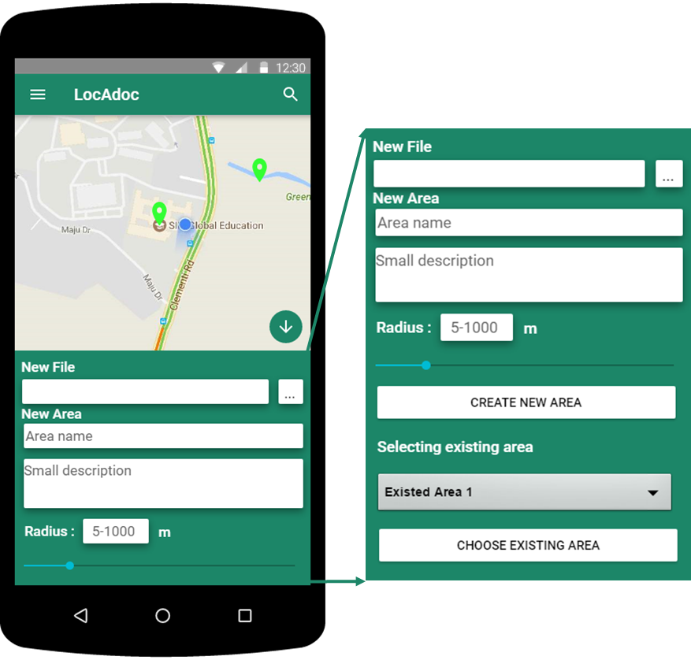

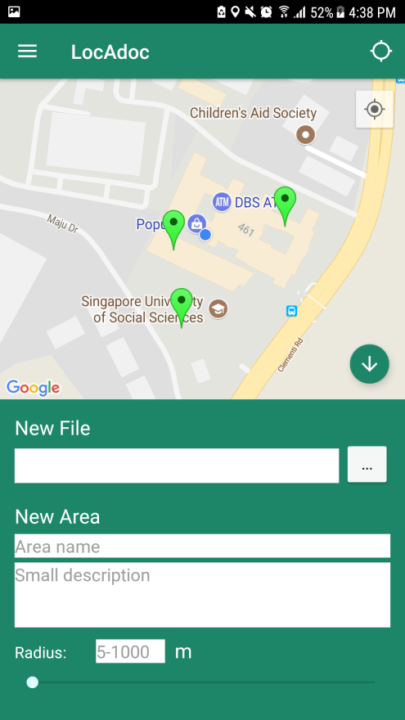 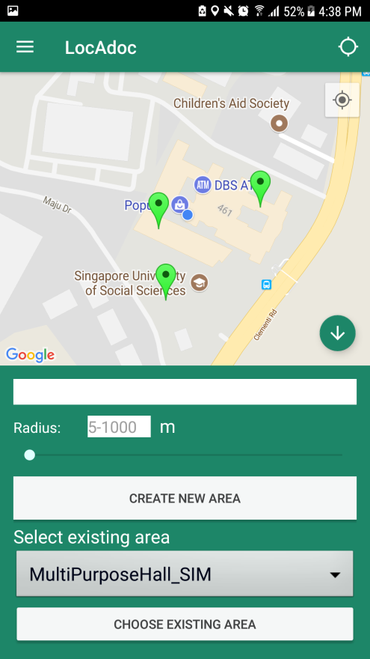

On clicking the add document button, a form to add area will appear from the bottom of the screen and all the buttons will be replaced with Hide Button

|  |  |
| --- | --- |
|  | 1. **Import Files button:** Open a new activity to select a pdf file in the device. Upon successful select, the name of the file will be displayed on the box in the right of the button. 2. **Area Name:** New area name (cannot be empty and must be at least 2 characters) 3. **Area Description:** New area description 4. Change Radius: 5. Create New Area Button 6. Existed Area List 7. Existing Area Selection Button |

## Settings

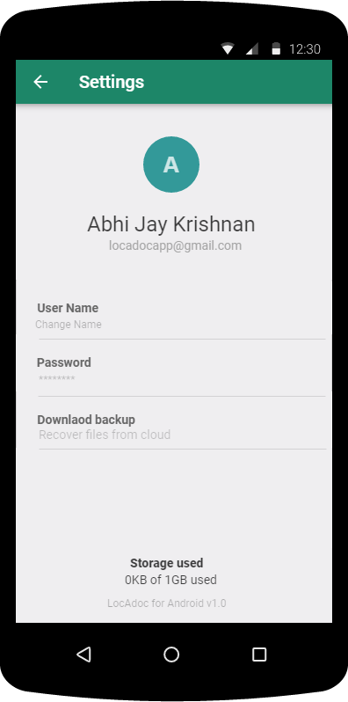 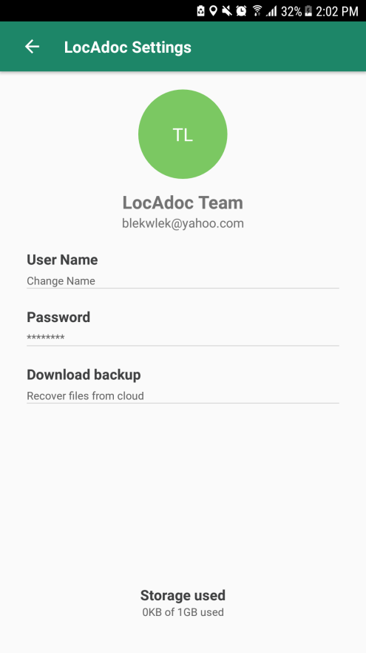

On this page, the user gets to edit his name and phone number. He may choose to download all his secured folder in AWS S3 by clicking on download backup. The user may also wish to delete his account on which it will send the user back to login page. On clicking password will open a new activity to change password.

|  |  |
| --- | --- |
|  | 1. **Go Back Menu in Settings**: Go back to Main Home Page 2. **Initial Name:** Show the User’s Name initial Name depends on the User’s first and last name 3. **Current User Name:** Show User’s first and last name and If user click this text, then it will open dialog for changing user name 4. **Current User Email:** Show User’s email account address 5. **Changing Name Menu:** Open dialog for changing user name 6. **Changing Password Menu:** Open new screen for changing user’s current password **Reference 3.11 Change Password** 7. **Download Backup Menu**: Download the backup files from cloud service to current devices 8. **Current File Usage:** show the user’s file usage |

## Change User Name

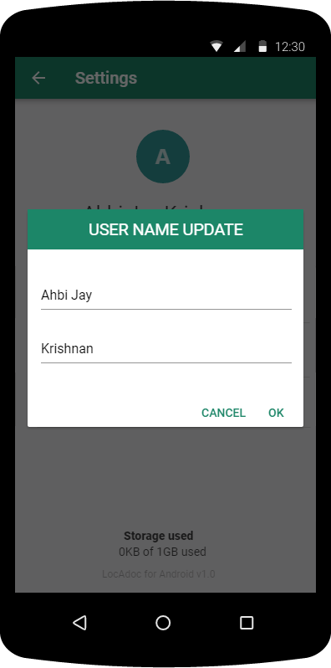 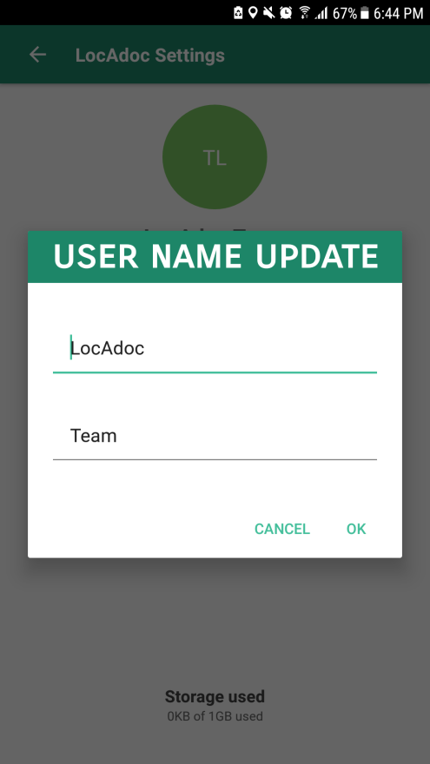

Explanation about Add Area Explanation about Add Area Explanation about Add Area Explanation about Add Area

|  |  |
| --- | --- |
|  | 1. First Name Field 2. Last Name Field 3. Cancel Button 4. OK Button |

## Change password

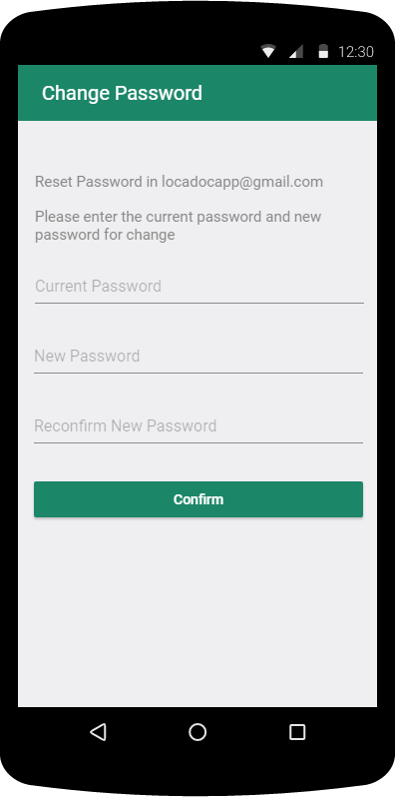 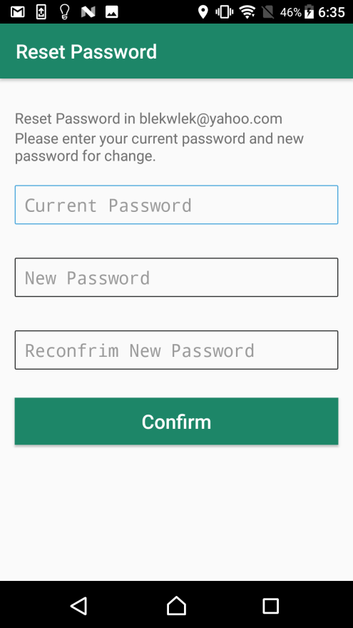

The user can change password by filling up the above form and clicking confirm on the top.

|  |  |
| --- | --- |
|  | 1. **Application message**: The Application show message that verification code is sent to user’s email 2. **Current Password**: User need to input current Password in User account 3. **New Password**: User need to input New Password for next login session    1. The password should contains both lower case and upper case letters    2. The password should contains at least one integer value    3. The password length should be between 8 and 12 character 4. **Confirmation New Password**: User need to input same values as New Password 5. **Confirmation Button**: Submission button with current Password and New Password for Account. **IF** correct current password, **THEN** the app will show success message **ELSE** **THEN** the app will show fail message. |

## Download Backup Files

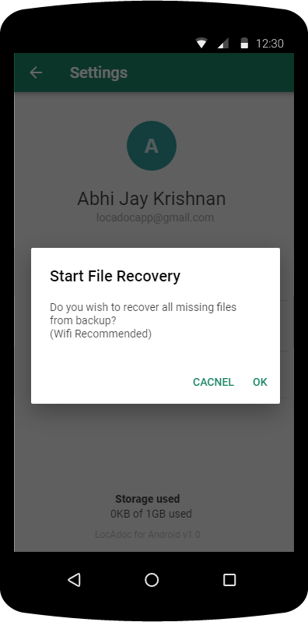 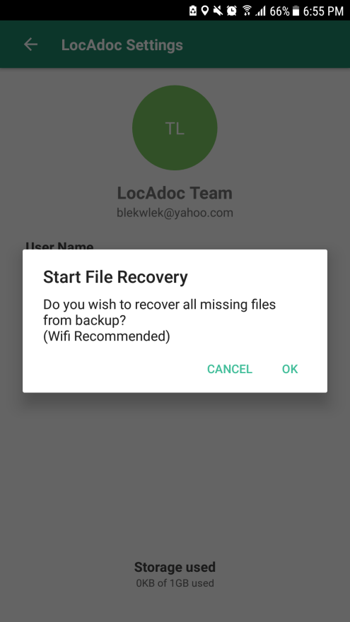

Explanation about Add Area Explanation about Add Area Explanation about Add Area Explanation about Add Area

|  |  |
| --- | --- |
|  | 1. OK Button 2. Cancel Button |

## About

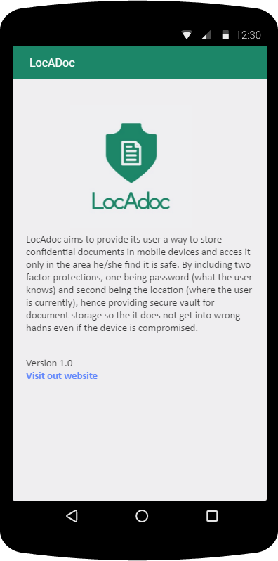 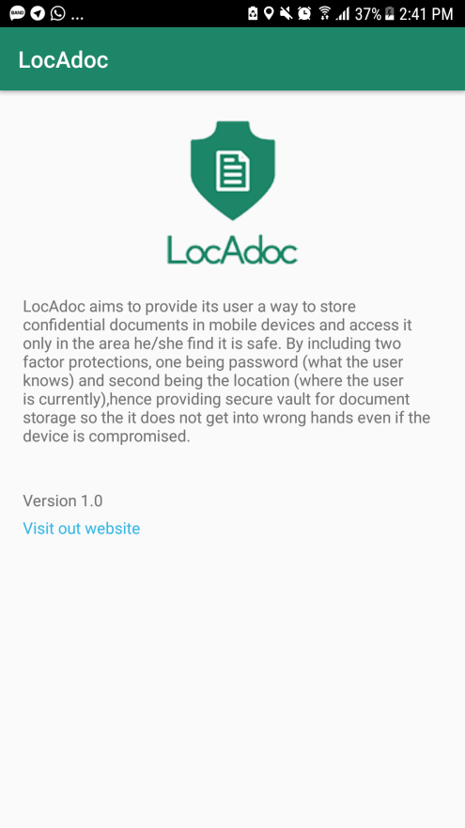

This activity can be reached from main menu and it describes the version of the application and credits.

|  |  |
| --- | --- |
|  | 1. **Visit website Link**: Open LocAdoc website 2. **Introduction in About Us** |